Experiment: 9
Massive MIMO Capacity vs SNR and Gain Using MATLAB
P.VENKATA KISHORE
192412581

OBJECTIVE:1:
Analyze the channel capacity of a Massive MIMO system for different signal-to-noise ratio (SNR) values using MATLAB. Observe how channel capacity increases with improving signal quality based on the Shannon capacity principle.

MATLAB CODE:

clc;
clear;
close all;
snr = 0:5:30;
snr_linear = 10.^(snr/10);
capacity = log2(1 + snr_linear);
figure;
plot(snr,capacity,'-o','LineWidth',2,'MarkerSize',6);
grid on;
xlabel('SNR (dB)');
ylabel('Channel Capacity (bps/Hz)');
title('Channel Capacity vs SNR');

OUTPUT:

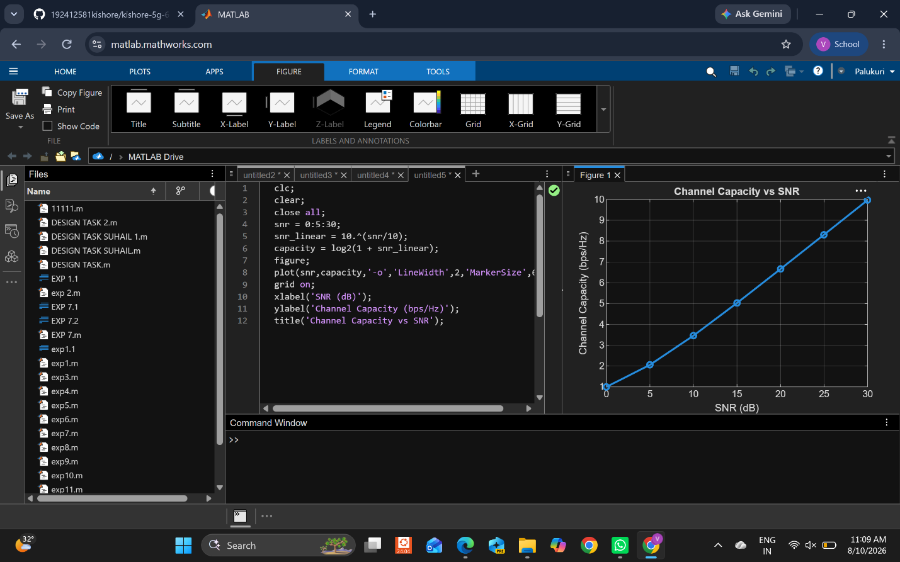

OBJECTIVE:2:
Compare the signal-to-noise ratio for different communication scenarios using MATLAB. Analyze the effect of SNR on the quality and reliability of wireless communication in Massive MIMO systems.

MATLAB CODE:

clc;
clear;
close all;
snr = 0:5:30;
snr_linear = 10.^(snr/10);
capacity = log2(1 + snr_linear);
figure;
plot(snr,capacity,'-o','LineWidth',2,'MarkerSize',6);
grid on;
xlabel('SNR (dB)');
ylabel('Channel Capacity (bps/Hz)');
title('Channel Capacity vs SNR');

OUTPUT:

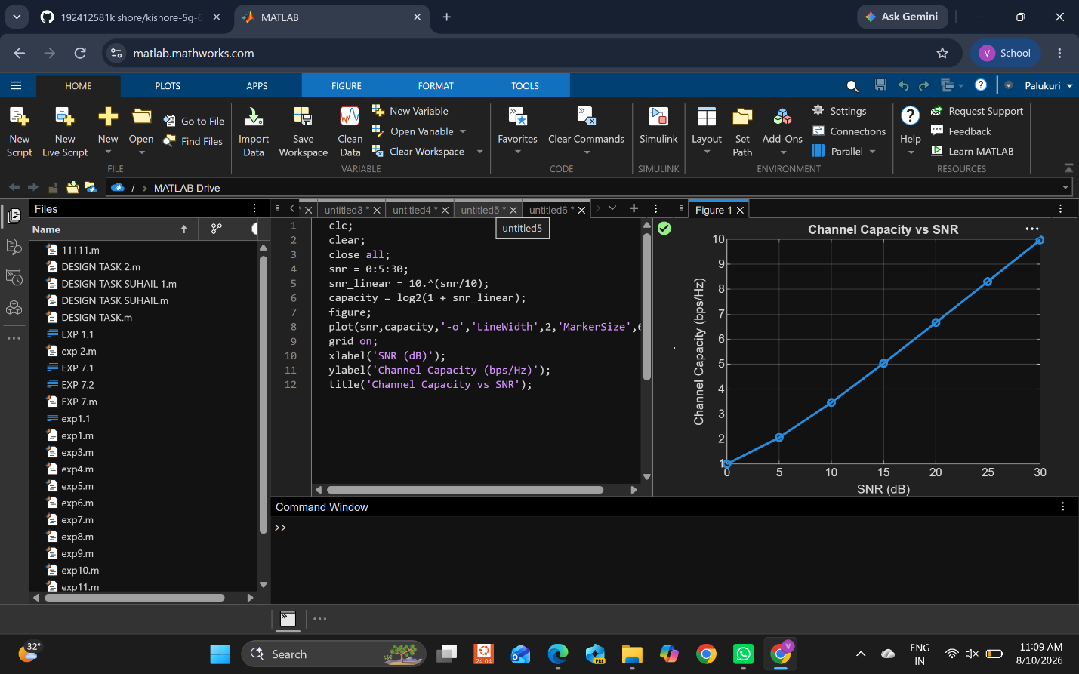

OBJECTIVE:3:
Analyze the antenna gain achieved by varying the number of antenna elements in a Massive MIMO system using MATLAB. Observe how increasing the antenna array size improves directional gain and enhances communication performance.

MATLAB CODE:

clc;
clear;
close all;
antennas = [4 8 16 32 64];
gain = 10*log10(antennas);
figure
bar(antennas, gain)
grid on
% Number of Antenna Elements
% Antenna Gain (dB)
xlabel('Number of Antenna Elements')
ylabel('Antenna Gain (dB)')
title('Antenna Gain for Different Antenna Array Sizes')

OUTPUT:

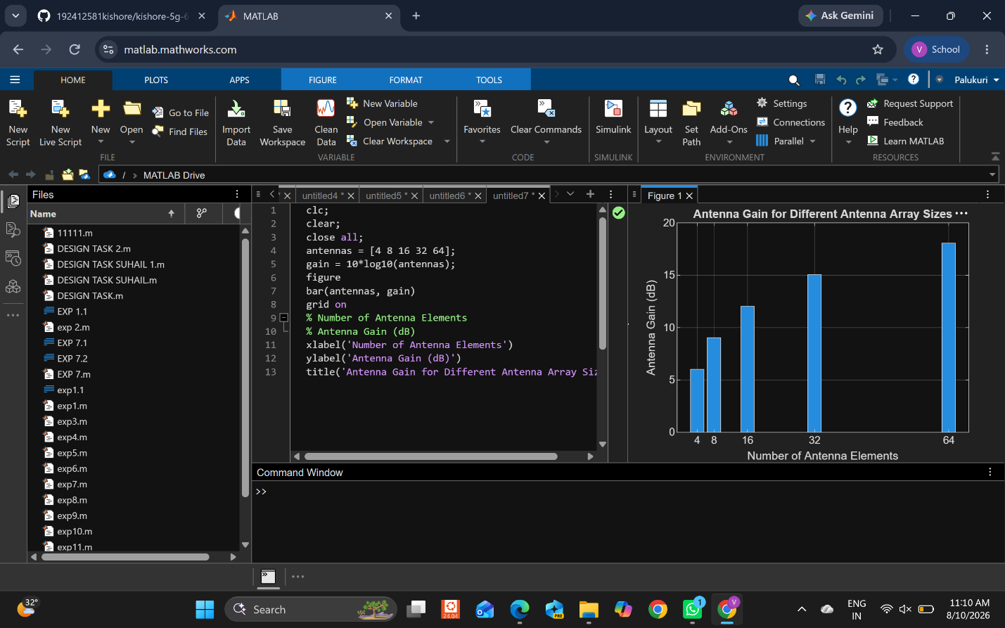

Result
The MATLAB analysis successfully demonstrated the relationship between channel capacity, signal-to-noise ratio, and antenna gain in a Massive MIMO system. The results showed that higher SNR and larger antenna arrays improve communication performance by increasing channel capacity and directional gain.

